Name___________________________________
Date__________________
Observations and Inferences

OBSERVATION
- An observation is a statement describing a fact.
- When you observe you become aware of something using one of your senses. If you see, smell, taste, or hear something you are observing it. You simply describe something as it appears.
- Sometimes scientists must make very careful observations. Often, their senses are not good enough. Some things can’t be observed using human sense. (Examples: radiation, sound waves, and atoms)
INFERENCE
- An inference is a statement based on an interpretation of the facts.
- When you infer you make a mental judgment based on observations.
- Inferences can’t be directly observed. They require thought.
- Example: You get up in the morning, look at the sky and observe dark clouds. The air is cool, humid, and you observe puddles on the ground. You might infer that it had rained recently. NOTE: You did not see it rain. You decided that it rained based upon your observations.
Practice: Your task is to determine if the following are observations or inferences. Put an “O” in front the observation and an “I” in front of the inferences.
- The temperature at noon was 78 degrees.
- It is a very hot day.
- The price of gasoline is rising.
- Bill’s car is very fast.
- The test was very easy.
- The candle weighed 71 grams.
- The test tube felt hot.
- The flowers did not grow due to the lack of sunshine.
- The dimension of the card is 3” x 5”.
- The Amoeba moved toward the light.
- The price of gasoline is unreasonable.
- There were three blue rulers on the table.
- With all of the clouds today, it will probably rain this afternoon.
- The car is red.
- The room is very quiet.
- All Wilmot teachers are cool.

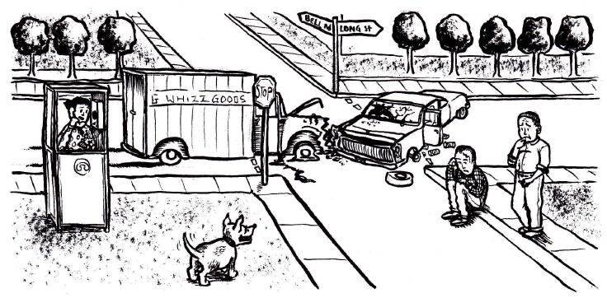
Using the picture above write 4 observations (2 Qualitative and 2 Quantitative) and 2 Inferences about the picture above.
Observations Inferences
Qualitative 1).
1). 2).
2).
Quantitative
1).
2).

