Name_________________________________Period____

NOTE OUTLINE: Chap 5 & 6: Rocks

Objectives

- Identify and explain characteristics of igneous rocks. This means that if I am given an igneous rock I:
  - Can use grain size to identify a rock as intrusive or extrusive. In addition, I can discuss how the rate of cooling is related to grain size.
  - Can use color to identify a rock as light or dark color.
  - Can identify based on color if the rock has more silica OR iron and magnesium.
  - Can use color to determine the type of magma (high viscosity v. low viscosity) that formed an igneous rock.
  - Can explain how he addition/removal of water will change the viscosity and melting temperature of magma.
  - Discuss the factors that affect how rocks melt & crystallize
  - Describe uses of igneous rocks.

- Identify and explain characteristics of sedimentary rocks. This means that I:
  - Can describe and list in order the steps that form most sedimentary rocks: Uplift, weathering (both physical and chemical), erosion, deposition, burial, lithification, cementation
  - Understand and explain how flowing water can affect the weathering and erosion processes.
  - Can identify a sedimentary rock that fits into one of the other subgroups; organic & chemical.
  - Describe uses of sedimentary rocks.

- Identify and explain characteristics of metamorphic. This means that I
  - Can identify a rock into a metamorphic subgroup; foliated vs. non-foliated
  - Explain the formation of metamorphic rocks and link the formation process to heat and/or pressure.

- Understand how rocks continuously change from 1 type to another in the rock cycle. This means I can:
  - List, describe and explain the processes and steps needed to turn an existing rock 3 different rock types.

- I can classify a given rock sample into:
  - One of the 3 main types of rock described above: igneous, sedimentary or metamorphic by using unique characteristics and/or processes that formed the rock.

Igneous Rock Definitions:

- Igneous Rocks: Rocks formed from ____________________________________________________

- Magma = molten rock found ________________Earth’s surface

- Lava = molten rock that reaches & flows_____________ Earth’s surface

Magma

- Origin of Magma:

  - Melting: The1st process in the formation of igneous rocks. Rocks must be ______________.

  - Hot enough temperatures are found in the ______________________ and _____________________

  - What heats the upper mantle & lower crust?

    - Heat left in __________________from Earth’s formation, & from _________________

    - ______________________decay of elements in mantle

Classification of Magma

Magma Type | Color of Rock Formed | Amount of Silicon & Oxygen | Amount of Iron & Magnesium | Viscosity of Magma | Volcanic Explosiveness
Rhyolitic
Basaltic

Water’s Effect on Magma

When the water content of rocks increases:

- Melting point ___________________

- Magma viscosity ____________________

- Magma explosiveness __________________ because:

  - Water turns to __________ in the hot magma

  - If the water vapor can’t escape from the magma, ___________________ causing an explosion.

  - Water vapor is the most abundant gas in magma

Main observations for igneous rock identification:

- Color: _____________ vs. ________________

- Grain size: ______________ vs. _______________

Location of Igneous Rock Formation

- Extrusive rocks: ________________igneous rocks that _________________on Earth’s surface

- Intrusive rocks: Coarse/large grained rocks due to ______________ cooling __________the surface

  - Examples: The most common intrusive rock is_________________

Igneous Rocks as Resources

- Building materials: They are ____________ & _______________ to weathering (example – granite)

Obsidian & Pumice:

- Obsidian: “Black glass”

  - Cooled ________________ that ______________ crystals are formed: ________________

- Pumice: 50% holes due to escape of trapped ____________

  - Used for abrasive polishing mixtures and cleansers

Sedimentary Rock Overview:

- Most sedimentary rocks are formed when sediments are _________________________________

- Sediments = Little pieces of solid material (pieces of __________________________________

_________________________________ that have been deposited on Earth’s surface

- This can happen by wind, water, ice, gravity, or chemical precipitation

- As the sediments get “cemented” together, they form sedimentary rocks

Processes/Steps to Form Sedimentary Rocks:

- Uplift: Rocks must be __________________ to Earth’s surface before the rest of the processes in the formation of sedimentary rock can occur.

- Weathering: Breaking down, ______________________ of rocks into sediments (which vary in size)

  - Chemical Weathering. Causes include

    - _______________ of rocks by _______________

    - Chemicals that change minerals in the rock (example: ______________)

  - Mechanical/Physical Weathering causes rock to __________________________ without

changing the chemical make-up of the rocks. Causes include:

    - _________(and length of time in moving water)

      - The ______________ it moves, the ____________it is

    - ______________________(AKA freeze & thaw)

    - Tree roots
    - Crystal growth

- Erosion: ___________________________________of sediments to new locations

  - Possible means: __________________________________________________________

  - How can you tell how far a rock piece has traveled?

    - If it is moved a SHORT distance, the rock pieces still have ________________ edges

    - The ________________it travels, the rock edges will become more ___________ as it bounces along

- Deposition: The process of ___________________ or ________________ of sediments on the ground or bottom of bodies of water

- Burial: Becomes ________________________________ beneath more & more sediments

- Lithification = Process that transforms sediments into sedimentary rocks.

- Lithification means “making of _______________” and has 2 parts

  - Compaction: Bottom layers of sediment are ______________ TIGHTLY together by the

_____________________________ of upper sediment layers

  - Cementation: Sediments are “cemented” or ____________ together by minerals in the water that crystalize.

  - Summary: Lithification turns ___________________ into _________________________
Features of Sedimentary Rocks:

- Layers

- Sedimentary rocks usually form in _______________________

- Sedimentary rock is the _______________________ rock on the ______________ (not in the crust) of Earth

- Fossils May Be Present:

  - Fossil = preserved _______________________________________ of once-living organisms

  - Only found in ____________________rocks. WHY?________________________________

  - During lithification, parts of organisms are replaced by _______________ & turned into rocks

Sec 6.2 Three main Groups of Sedimentary Rocks
- Classification is based on how they form, including what they are made of
- Most Common (AKA Clastic)
- Organic
- Chemical

Sedimentary Rock Type | Made from | Subtypes & examples
Most  Common  (AKA Clastic) | _______________ | 3 subgroups based on grain size:  - Large-grained  - Due to ___________________ & speeds which can carry large pieces.  - Example high energy water: ___________ __________________________________  - Medium-grained: _____________-sized  - Valuable reservoirs of ______________________  - Small-grained:  - These are made of sediments ________________  - Only deposits in __________________________
Organic | _______________  _______________ | - ORGANIC Limestone: _______________________  - ___________: rock from buried swamp plants
Chemical | _______________- minerals left behind when __________  _______________ | Example: ______________________________  Example locations:  - Coast of _______________ or the _________________

Uses of Sedimentary Rocks:

- Energy

  - ____________________

  - Reservoir for ________________________when _________________ (open space) present

- Limestone to make ____________________

Metamorphic Rocks

- Metamorphic Rocks = Rocks that change form while _______________________________

- Method of Formation:

  - _____________________and ______________increase with depth

  - Temperature and pressure combine to alter the rock ________________________________ (If it melts, igneous rock is formed instead)

  - ________________________ is due to Earth’s internal heat

  - ____________________ comes from overlying rocks or tectonic plate movement

- Types of Metamorphic Rocks

  - Foliated Metamorphic Rocks have ____________________ or ______________________ mineral crystals

    - Lines may be straight or wavy

    - The minerals have been squeezed into parallel layers by intense ________________

  - Non-foliated Metamorphic Rocks – Rocks that ___________________________________ of crystals

    - The majority of these are formed by extreme_________________________________

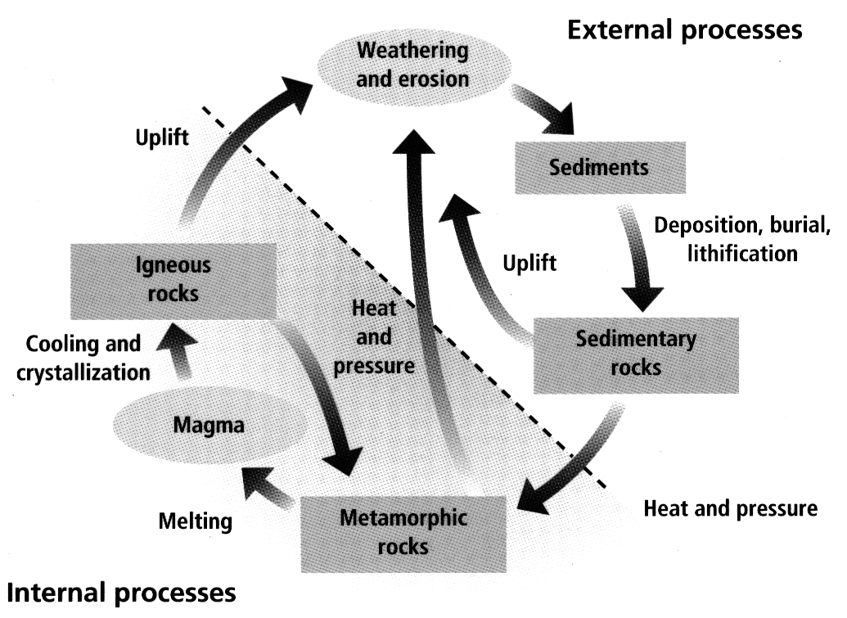

The Rock Cycle:

- Is the _________________________________________________________ of rock

- The type of rock that results is based on how new rock type is formed.

- Describe how an igneous rock could change into:

  - Metamorphic Rock:

  - Sedimentary Rock:

  - Igneous Rock:

Comparison of the Characteristics of the 3 rock types:



