Name____________________________Period____

Chapter 12 Meteorology Review

Vocabulary words included on the exam. Study them, make flashcards, use Quizlet for flashcards, review games & quizzes. Be ready to define, use, relate, and compare/contrast them.
- BE SURE TO REVIEW Chapter 12 Vocabulary Sheet

Review Questions:

- Complete the “Characteristics of Air Masses” table:
Symbol | Name | Relative temp | Relative humidity | Example source location (that could affect U.S.weather)
mP
cP
mT
cT

- What are the 2 characteristics we classify air masses by?

- As a cT air mass that formed over Mexico moves north into the United States through New Mexico, Colorado, Nebraska, etc., what would be the major change in the air masses 2 main characteristics? Explain why.

- Complete the “Characteristics of Fronts” table:
Type | Relative Steepness  of Front | Type of Clouds | Relative Severity of Storms | Map Symbol  (Color, shape) | Basic Description | How ID from Side View?  (Draw or describe)
Cold Front
Warm Front
Stationary Front | XXXXXXX  XXXXXXX | XXXXXXXX  XXXXXXXX
Occluded Front | XXXXXXX  XXXXXXX | XXXXXXXX  XXXXXXXX

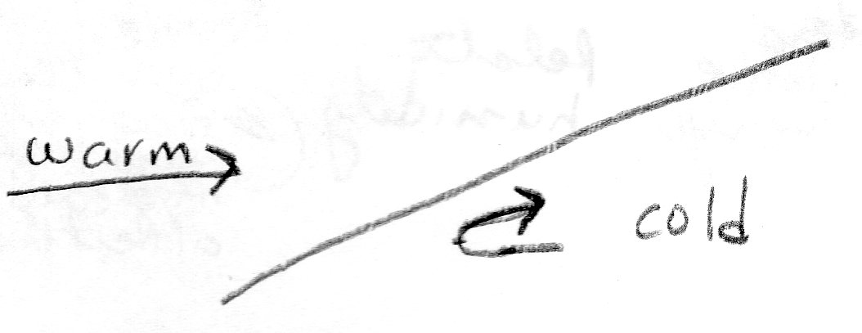
- What type of front is shown in the diagram to the right? How do you know?

- Draw the clouds typically seen at this front along the front line.

- How many air masses are involved in an Occluded Front?

- Before the occluded front formed, what were 2 types of fronts were originally present? Explain what caused the occluded front to form.

- Three of the fronts only involve the meeting of a warm and a cool air mass. What determines which of the three front types occurs? Explain.

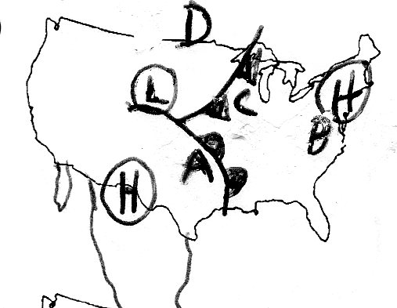

Use the diagram to the right to answer questions # 10-18:

- What type of front is near A in the diagram above?

- What direction is the front near A moving?

- What type of air mass is A likely to be under?

- What type of air mass is D likely to be under?

- Which location (A, B, C, D) is likely to have a steady rain, but not a thunderstorm?

- Which location (A, B, C, D) is likely to have sunny skies?

- Which location on the map(A,B,C,D) is likely to have the highest temperature of 82F.?

- Which location (A,B,C,D) is likely to have the lowest temperature of 45F?

- Make a forecast about what weather would be like based on the front closest to C. Explain how the weather is likely to change given conditions evident on the map. Reference things such as:
- temperature before/after
- direction the wind comes from
- strength and duration (time) of precipitation
- types of clouds

- Complete the following table about pressure systems:
System | Does Air Rise or Sink? | Usual weather Explain why that type of weather is found there | Explain WHY that type of weather is found here
Low-Pressure
High-Pressure

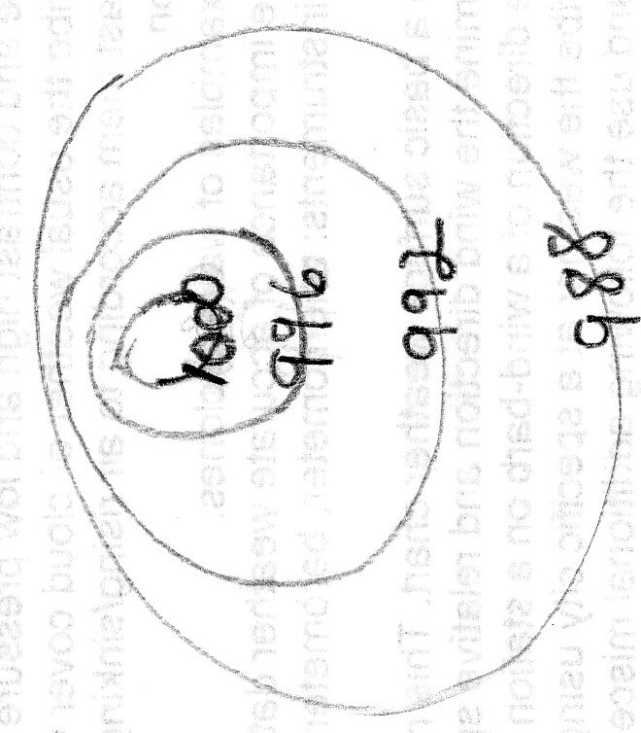
- On the isobar diagram to the right, circle the area with the greatest wind speed. Then explain how you know the wind speed is greatest there.

- Is the center of the isobar diagram a high or low pressure center? Put an H or an L, as appropriate in the center.

- In the isobar diagram, based on the isobar values, draw an arrow showing the direction the wind is blowing.

- Compare and contrast an isotherm and an isobar. (May use a Venn diagram or table if you want). Must include a similarity and for the difference describe both.

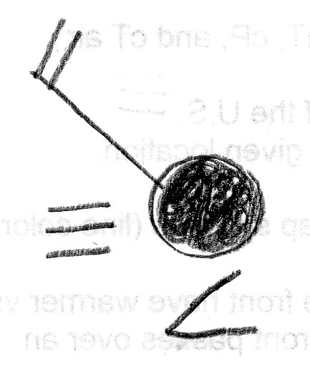
- Using a weather station model symbol key (from a worksheet, p. 915of your book, or link on teacher webpage), describe five weather characteristics based on the station model diagram to the right.
78
65

- Draw a weather station model for the following city based on the data below:
Temperature | Cloud Cover | Wind Direction | Dew Point | Wind Speed | Precipitation
52 | Cloudy | West | 52 | 25 mph | Heavy Rain

- Synthesis: Describe in a short (around 4 sentences) but thorough and detailed explanation how the 3 terms continental polar, maritime tropical, and warm front could be related to each other to produce rain. (Similar type question on test is worth 3 points.

