Intro to Half-Life PhET Lab (Radioactive Dating Game) Name ________________________ Period____
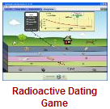

Introduction: Radioactive particles decay. What does it mean when a substance is radioactive? In this simulation, you will investigate the concept of half-life.

Procedure:
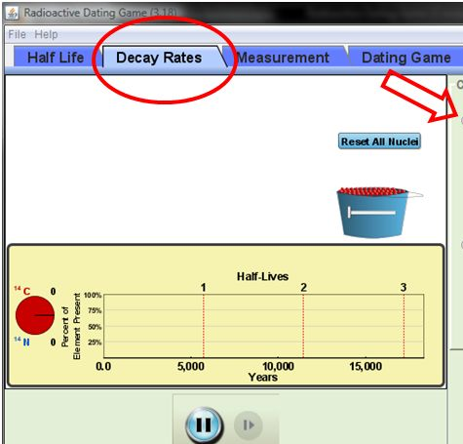
- Go to the following link: https://phet.colorado.edu/en/simulation/radioactive-dating-gameand and hit the “Play” arrow.
- Play around with the simulation for a few minutes.
Carbon-14
- Click on the tab for Decay Rates. Check Carbon-14.
- Click on the bucket and add some nuclei to the simulation. Observe what happens.

- What do the red dots represent? _________________________________________
- What do the blue dots represent? _________________________________________

- Use the Stop and Play buttons to control how fast the decay occurs.

- Explain what happens to the Carbon-14 atoms as the simulation goes on: _____________________________________________________________________________________ ______________________________________________________________________________________

- Do all the Carbon-14 atoms decay at the same time? Explain________________________________________________________________________________ ______________________________________________________________________________________

- Do any of the Nitrogen-14 atoms change back to Carbon-14 atoms? _________________

- Let the graph run to completion and fill in the following table using the Half-Life graph.:
# of Half-Lives | % Carbon Remaining | Approximate Age in Years
0
1
2
3

- Approximately how many years separate each half-life event?__________________________

Uranium-238
- Click on the tab for Decay Rates. Check Uranium-238.

- Click on the bucket and add some nuclei to the simulation. Observe what happens.

- What do the green dots represent? _________________________________________

- What do the gray dots represent? _________________________________________

- Explain what happens to the Uranium-238 atoms as the simulation goes on: _____________________________________________________________________________________ ______________________________________________________________________________________
- Do all the Uranium-238 atoms decay at the same time? Explain________________________________________________________________________________ ______________________________________________________________________________________

- Do any of the Lead-206 atoms change back to Uranium-238 atoms? _________________

- Let the graph run to completion and fill in the following table using the Half-Life graph.:
# of Half-Lives | % Uranium Remaining | Approximate Age in Years
0
1
2
3

- Approximately how many years separate each half-life event?__________________________

Analysis: Examine the data tables for both Carbon-14 and uranium-238.
- Explain what happens to the percent of the original element each time a half-life occurs.

- Explain what happens to the percent of the new element each time a helf-life occurs.

- Explain how the time between each half-life compares for:
  - Carbon:

  - Uranium:

