Name _________________________Period_________

Minerals & Planet Formation Review Sheet

- List the 5 characteristics that all minerals have. (NOTE – these are NOT tests like color, streak, etc.)

- Not a mineral:

  - Why isn’t sugar considered a mineral?

  - List another substance found below earth’s surface that is not a mineral. Explain why it is not a mineral. (See your notes.)

- Define each of the following tests.

  - Color

  - Luster

  - Texture

  - Streak

  - Hardness

  - Cleavage

  - Fracture

- Which of the tests above is the LEAST reliable? Why?

- What are the 2 main classifications of luster?

- Explain how you determine hardness.

- What are the 2 types of liquids that minerals can form from?

- What is the name for molten material:

  - Beneath earth’s surface?

  - On earth’s surface?

- What size of mineral crystals form if magma cools slowly?__________Cools quickly?__________

- What are the 2 main conditions needed for the formation of large crystals?

- What are the 2 most common elements in the crust of the earth?

- Complete the following chart, listing the most common elements found in each of the following mineral categories.

Mineral Category | Elements Commonly Associated with the Category
Light-colored Silicates
Dark-colored Silicates
Carbonates

- Many minerals come in a variety of colors.

  - What causes the color variation in Quartz & other minerals?

  - Does variation in color cause as difference in the geometric shape of a given mineral? (Hint- think of the Eggshell Geode Lab. What shape should both table salt, the clear Geode crystals and the colored geode minerals have been?)

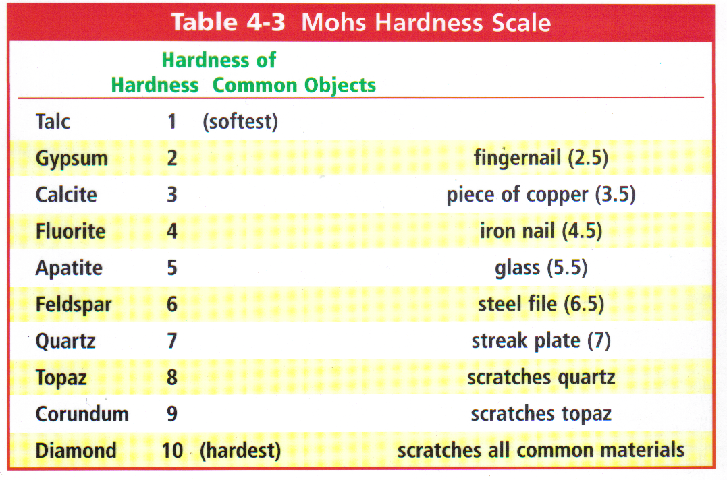
Use the Mohs Hardness Scale above to answer the next few questions:
- What does it tell you if a mineral scratches glass?

- If Gypsum is rubbed against Talc:
  - Is a scratch made, or no scratch?

  - Is a streak left behind? Why or why not?

- What happens if mineral with hardness of 3.4 is rubbed against the following. In other words, is a scratch made? Is there no scratch? A possibility of a streak?
  - Feldspar?

  - Calcite?

- A mineral scratches gypsum, but not apatite:
  - What is its possible hardness range?

  - How could you further determine its hardness? Be specific.
- Use the attached flow chart to identify the minerals with the following characteristics: (1 pt each)
  - Dark red color, fracture, non-metallic, does not scratch glass, red streak

Name of mineral is__________________

  - Black, magnetic, metallic, black streak

Name of mineral is__________________

  - Glassy, shatters when it breaks, hardness 7, scratches glass, non-metallic, pale pink color

Name of mineral is__________________ (If you’re not sure on this 1, is there something else you would look for?)

  - Breaks along a flat surface/plane, non-metallic, dark green, doesn’t scratch glass

Name of mineral is__________________
