Name _______________________Period ___

Lab: Ocean Surface Currents

Background Information
Ocean surface currents are an important part of the heating process on Earth’s surface. Knowledge of the surface currents provide us with a better understanding of global climate and weather patterns, as well as living conditions, migration patterns, and life cycles of plants and animals. Studying ocean currents can also be useful in ship navigation, which has a direct impact on the economy, search and rescue operations, and tracking oil spills.

Big Idea/Essential Question: What factors influence the flow patterns of ocean surface currents?

Purpose: Students will…
- Simulate ocean surface currents
- Observe how winds cause surface currents and how landmasses affect the movement of the currents.
- Understand how currents affect weather and climate.

Materials: Shallow pan, objects to represent landmasses, pepper, straws with a flexible neck, paper towels for spills

Procedure
- Fill the shallow pan ½ full of water.
- Sprinkle pepper on the water.
- From 2 opposite corners, have 2 group members use their straw to gently blow across the water’s surface.

- In the pan above, SKETCH the path of the pepper’s movement as you were blowing “wind”.

- PREDICTION. Place a rock in the water so that it is only partially submerged. The object represents a landmass. BEFORE blowing through the straws, draw your PREDICTION (in RED) about what effect this “landmass” will have on the movement of pepper.

- Blow through the straws from the same directions as before and observe the movement of pepper. In the pan above, SKETCH (in GREEN) the path of the pepper as it encounters the landmass. Be sure to include the landmass in your drawing.

- Add a 2nd partially submerged object in the water. BEFORE blowing through the straws, draw (in RED) your PREDICTION about what effect this 2nd “landmass” will have on the movement of pepper.

- Blow through the straws from the same directions as before and observe the movement of pepper. In the pan above, SKETCH (in GREEN) the path of the pepper as it encounters the 2 landmasses. Be sure to include the 2 landmasses in your drawing.

ANALYSIS:
- In this model, what did blowing through the straw represent?

- In this model, what did the objects placed in the water represent?

- Why was pepper needed in this model?

- Did the pepper move in the path you expected?
  - If YES, explain what knowledge you used to make your predictions. You cannot just say that you guessed!
  - If NO, explain what was different in your prediction and the observed movement of the pepper.

- Depth:
  - Did the “wind” affect surface particles and particles on the bottom to the same degree? Explain.

  - Predict which layer of the ocean the atmospheric winds have the most effect on. Explain your choice.

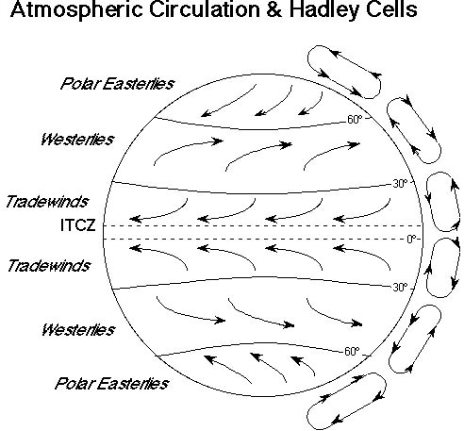
- Using the map of the Global Winds to the right, predict the direction the main currents flow at the following latitudes. Circle your PREDICTIONS.

  - 10ºN/S (near Equator) W E OR W E

  - 40º N/S : W E OR W E

  - 70º N/S: W E OR W E

- Use the Major Ocean Surface Currents map on page 19 of your note packet. Compare your predictions from the question above to the ACTUAL ocean surface currents:

  - 10ºN/S (Equator): W E OR W E

  - 40º N/S : W E OR W E

  - 70º N/S: W E OR W E

- Use the Major Ocean Surface Currents map on page 19 of your note packet. Locate the following 2 currents. Examine the current arrows that show where the current is coming from and where it is going.

Predict what temperature of water the current would be carrying AND why you chose that prediction:

  - Peru Current:

  - E. Australian Current:

- Based on your observations of the shallow pan and the Major Ocean Surface Currents map on page 19 of your note packet, what factors other than winds influence ocean surface currents?

CONCLUSION instructions on next page
CONCLUSION: Use a few sentences to discuss the following:
- What was the most important thing you learned about ocean currents by doing this lab activity?
- What questions do you still have? (You have to have some type of question! )
- What difficulties did you have in the lab?
- Even if your lab worked as expected, what could be 2 different sources of error in this lab?

