Name__________________________Period_____

Salinity Lab
Background Information
Temperature and salinity (the amount of dissolved salts in the water) affect the density of the water. Ocean salinity differs by small numbers, so oceanographers need to be accurate when measuring salinity. Changes in density caused by wind and currents at the surface affects the deep-ocean currents. Density ultimately affects the objects that are existing in the water, such as whales, seaweed, and submarines. The saltier the water, the more buoyant an object becomes. Therefore, salt waters are constantly trying to find their “place” in the ocean according to their salinity. Less salty water is less dense and will float on top of the more dense salty water.

Of course the layers are more complicated than this, but for this activity, you should be able to understand that salt or fresh water drops are going to want to “hang out” in water with similar properties. So fresh water drops will rise to the fresh water layer and salt water drops will sink to the salt water layer. The salinity of the water mixes, or changes, only when vigorously stirred. The U.S. Navy pays close attention to ocean salinity to be sure they know how submarines will travel as the move through the different waters of the world.

Materials:
- CLEAR Tap water (100ml beaker ½ - ¾ full)
- CLEAR Very Salty water (100ml beaker ½ full)
- VERY Blue Tap water (100 ml beaker ½ - ¾ full)
- DARK Green Very Salty water (Test tube)
- Red slightly salty water (Test tube)
- White paper (to put under beakers to see color)
- Masking tape & pen to label beakers
- Plastic spoon
- Medicine dropper
NOTE/CAUTION:
- You MUST rinse the dropper EVERY time you use it, BEFORE you put in the same or another beaker to prevent altering the “saltiness” of the beakers.
- All water solutions must be at the same temperature, room temperature.
Directions:
Part I
- Fill the small beaker ¾ full with clear tap water and place ON A WHITE PAPER.
- Fill medicine dropper with very salty green water
- Insert the dropper ½ way into beaker and gently squeeze 1-2 drops of the very salty green water into the beaker with clear water. (NOTE: Look from the SIDE of the beaker, not the top, to observe.)
- Record your observations:

Part II
- Fill the small beaker ¾ full with clear very salty water
- Fill medicine dropper with very blue tap water
- Insert the dropper ½ way into beaker and gently squeeze 1-2 drops of the very blue tap water into the beaker with clear water. (NOTE: Look from the SIDE of the beaker, not the top, to observe.)
- Record your observations:
Part III
- Continue to use the very salty water beaker used in Part 2.
- Pour approximately 50ml of VERY blue tap water SLOWLY down the side into the beaker on top of the very salty clear water.
- Record your observations:

- MAKING SURE that the dropper is CLEAN, fill the dropper with slightly salty red water.
- Place the dropper at the bottom of the clear layer of very salty water and squeeze out 1-2 drops of the slightly salty red water. (Be careful NOT to draw the clear salty water into the dropper.)
- Record your observations:

- Take the same dropper of slightly salty red water and place it into the top layer of blue tap water and squeeze out 1-2 drops of the slightly salty red water.
- Record your observations:

- Using the plastic spoon, mix the layered water system together.
- Record your observations:

ANALYSIS QUESTIONS
- In Part I, what happened to the drop of very salty green water in the tap water? Explain WHY that happened.

- In Part II, what happened to the drop of blue tap water in the clear salty water? Explain WHY that happened.

- In the large beaker in Part III, why did the blue tap water and very salty clear water not mix together?

- In Part III, what happened when the 2 drops of slightly salty red water were added to clear and blue layers? Explain WHY that happened.

CRITICAL THINKING & APPLICATION QUESTIONS
- When the Mississippi River flows into the Gulf of Mexico:
  - Does the river water rise or sink in the Gulf? Explain.

  - Review Part I and Part II, is the Mississippi flowing into the Gulf, most similar to what happened in Part I or Part II? EXPLAIN.

- When water freezes at the poles,
  - What happens to the density of the water under the ice? Explain.

  - Would the water under the ice, act more like the very salty water in Part I or the blue tap water in Part II?

Latitude | Atlantic  Salinity ppm | Pacific  Salinity ppm
60⁰N | 33.0 | 31.0
30⁰N | 36.7 | 34.2
0⁰ | 35.0 | 34.3
30⁰S | 36.2 | 35.7
60⁰S | 33.9 | 34.0

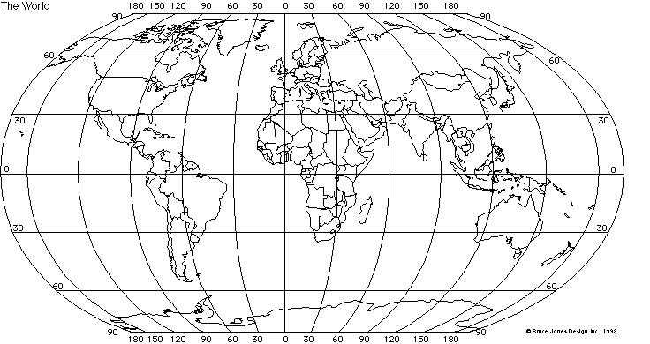

- The table above lists the approximate surface water salinities at various latitudes in the Atlantic and Pacific Oceans.

  - Based on the table, at which 2 latitudes are the salinities the highest?

  - Based on your knowledge of the global wind systems and what happens at latitudes of 0, 30, and 60, suggest a reason WHY the salinities are highest at the latitude you listed above. Be specific.

CONCLUSION: Use a few sentences to discuss the following: What was the most important thing you learned about salinity or density by doing this lab activity? What questions do you still have? What difficulties did you have in the lab? Even if your lab worked as expected, what could be 2 different sources of error in this lab? (If you need more space, use the back of this page to write your conclusion.)

