Inverse-Square Law Lab

Background: Why does the world get dark so fast outside the circle of the campfire? We all know that the farther away we get, the dimmer a light will look. The question of how much dimmer it looks was answered a long time ago. Today, we will repeat the discovery of the inverse square law made long ago by Sir Isaac Newton.

Pre-Lab Questions:
- What is the inverse square law?

- What two factors affect the strength of gravity pulling on an object?

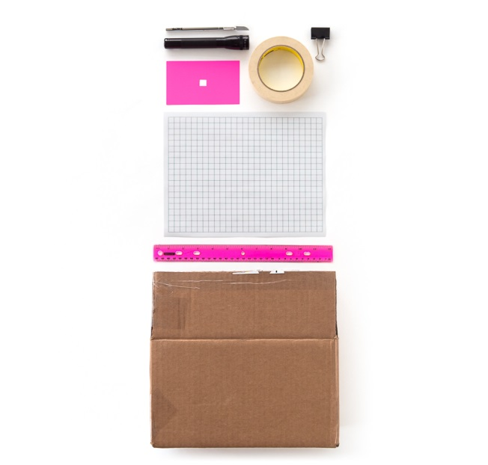
Tools and Materials

- A small flashlight
- Ruler
- A 3 x 5 index card
- Scissors
- A medium-size binder clip
- Graph paper (if using metric, use graph paper with 1-cm squares)
- Cardboard box piece
- Masking Tape

Procedure
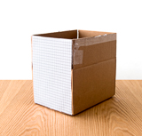
- Use your ruler to measure a 1 x 1-cm square in the center of the index card.
- Mark the square.
- Cut the 1 x 1-cm square out of the center of the index card using scissors.
- Clip the binder clip to the bottom of the card to make a stand.
- Mount the graph paper on the side of the cardboard box to make a screen.
- Position the card 2 centimeters in front of the graph paper.
- Line up the flashlight, square hole, and graph paper so that when the light shines through the hole you see a square of light on the graph paper.
- Put the graph paper at different distances from the bulb.
- Each time you move the graph paper, measure and record the distance from the index card to the graph paper in your data table.
- After measuring the distance, count how many squares on the graph paper are lit by the flashlight.
- Record the number of lit squares in your data table to match the distance the graph paper is at from the notecard.

Distance from notecard to graph paper (cm) | Number of Squares Lit by the flashlight | Observed Brightness/Light Intensity  (Brighter or Dimmer)

2 cm

1 cm

3 cm

0.5 cm

5 cm

10 cm

20 cm

Data Table:

Post-Lab Questions:
- What happens to the number of squares lit by the flashlight as you move the graph paper away from the index card?

- What happens to the number of squares lit by the flashlight as you move the graph paper toward the index card?

- What happens to the intensity/brightness of the light on the graph paper when it is moved away from the index card?

- What happens to the intensity/brightness of the light on the graph paper when it is moved closer to the index card?

- Think of intensity/brightness of the light as representing the strength of gravitational attraction between the light and the graph paper.
  - What distance would result in the strongest gravitational pull (brightest light)? Why?

  - What distance would result in the weakest gravitational pull (brightest light)? Why?

Extension

The intensity of light is the power per area on the graph paper. Since the energy that comes through the hole you cut is spread out over a larger area, the intensity of the light decreases when you move the graph paper away from the index card. Since the area the light touches increases as the square of the distance, the intensity/brightness of the light must decrease as the inverse square of the distance. Thus, intensity/brightness follows the inverse-square law.
The inverse-square law applies not only to the intensity of light but also to gravitational attractions. The pull of a planet’s gravity is directly proportional to mass of a planet; if you increase the mass you increase the gravitational pull it has on other objects. However, distance is related to gravitational pull following the inverse-square law. The farther apart two objects are, the weaker the effect of the gravitational pull becomes.

Using your knowledge of the inverse square law, describe the strength of gravitational pull between objects in the following situations:

1. Describe the strength of gravitational pull between one large planet and a nearby small moon.

2. Describe the strength of gravitational pull between two nearby large planets.

3. Describe the strength of gravitational pull between one large planet and a far-away small moon.

4. Rank the situations above, in questions 1-3, in order from strongest to weakest gravitational attraction.

5. Explain how you decided what situation showcased the weakest gravitational pull.

6. Explain how you decided what situation showcased the strongest gravitational pull.

