Exercise 4 LABORATORY REPORT
Name __________________________

Period __________ Date __________
Conformations of Alkanes and
Cycloalkanes (Using Molecular Model Kits)

Molecular Model Atom Colors: Carbon = Black Hydrogen = White Chlorine = Green

The Conformations of Ethane
Staggered Ethane Conformation:
- ________________________________________________________________________________

- ________________________________________________________________________________

________________________________________________________________________________
Eclipsed Ethane Conformation:
- Drawings of Eclipsed Ethane

Newman (“Straight on”) Sawhorse Dashed Wedge-Solid Wedge (Side View)

- Planes of Symmetry in Eclipsed Ethane

A._____________________________________________________________________________________

B._____________________________________________________________________________________

- Rotational Axes of Symmetry in Eclipsed Ethane

A._____________________________________________________________________________________

B._____________________________________________________________________________________

- Comparing staggered vs. eclipsed conformations of Ethane:

A._______________

B._______________

- ________________________________________________________________________________

- ________________________________________________________________________________

________________________________________________________________________________________

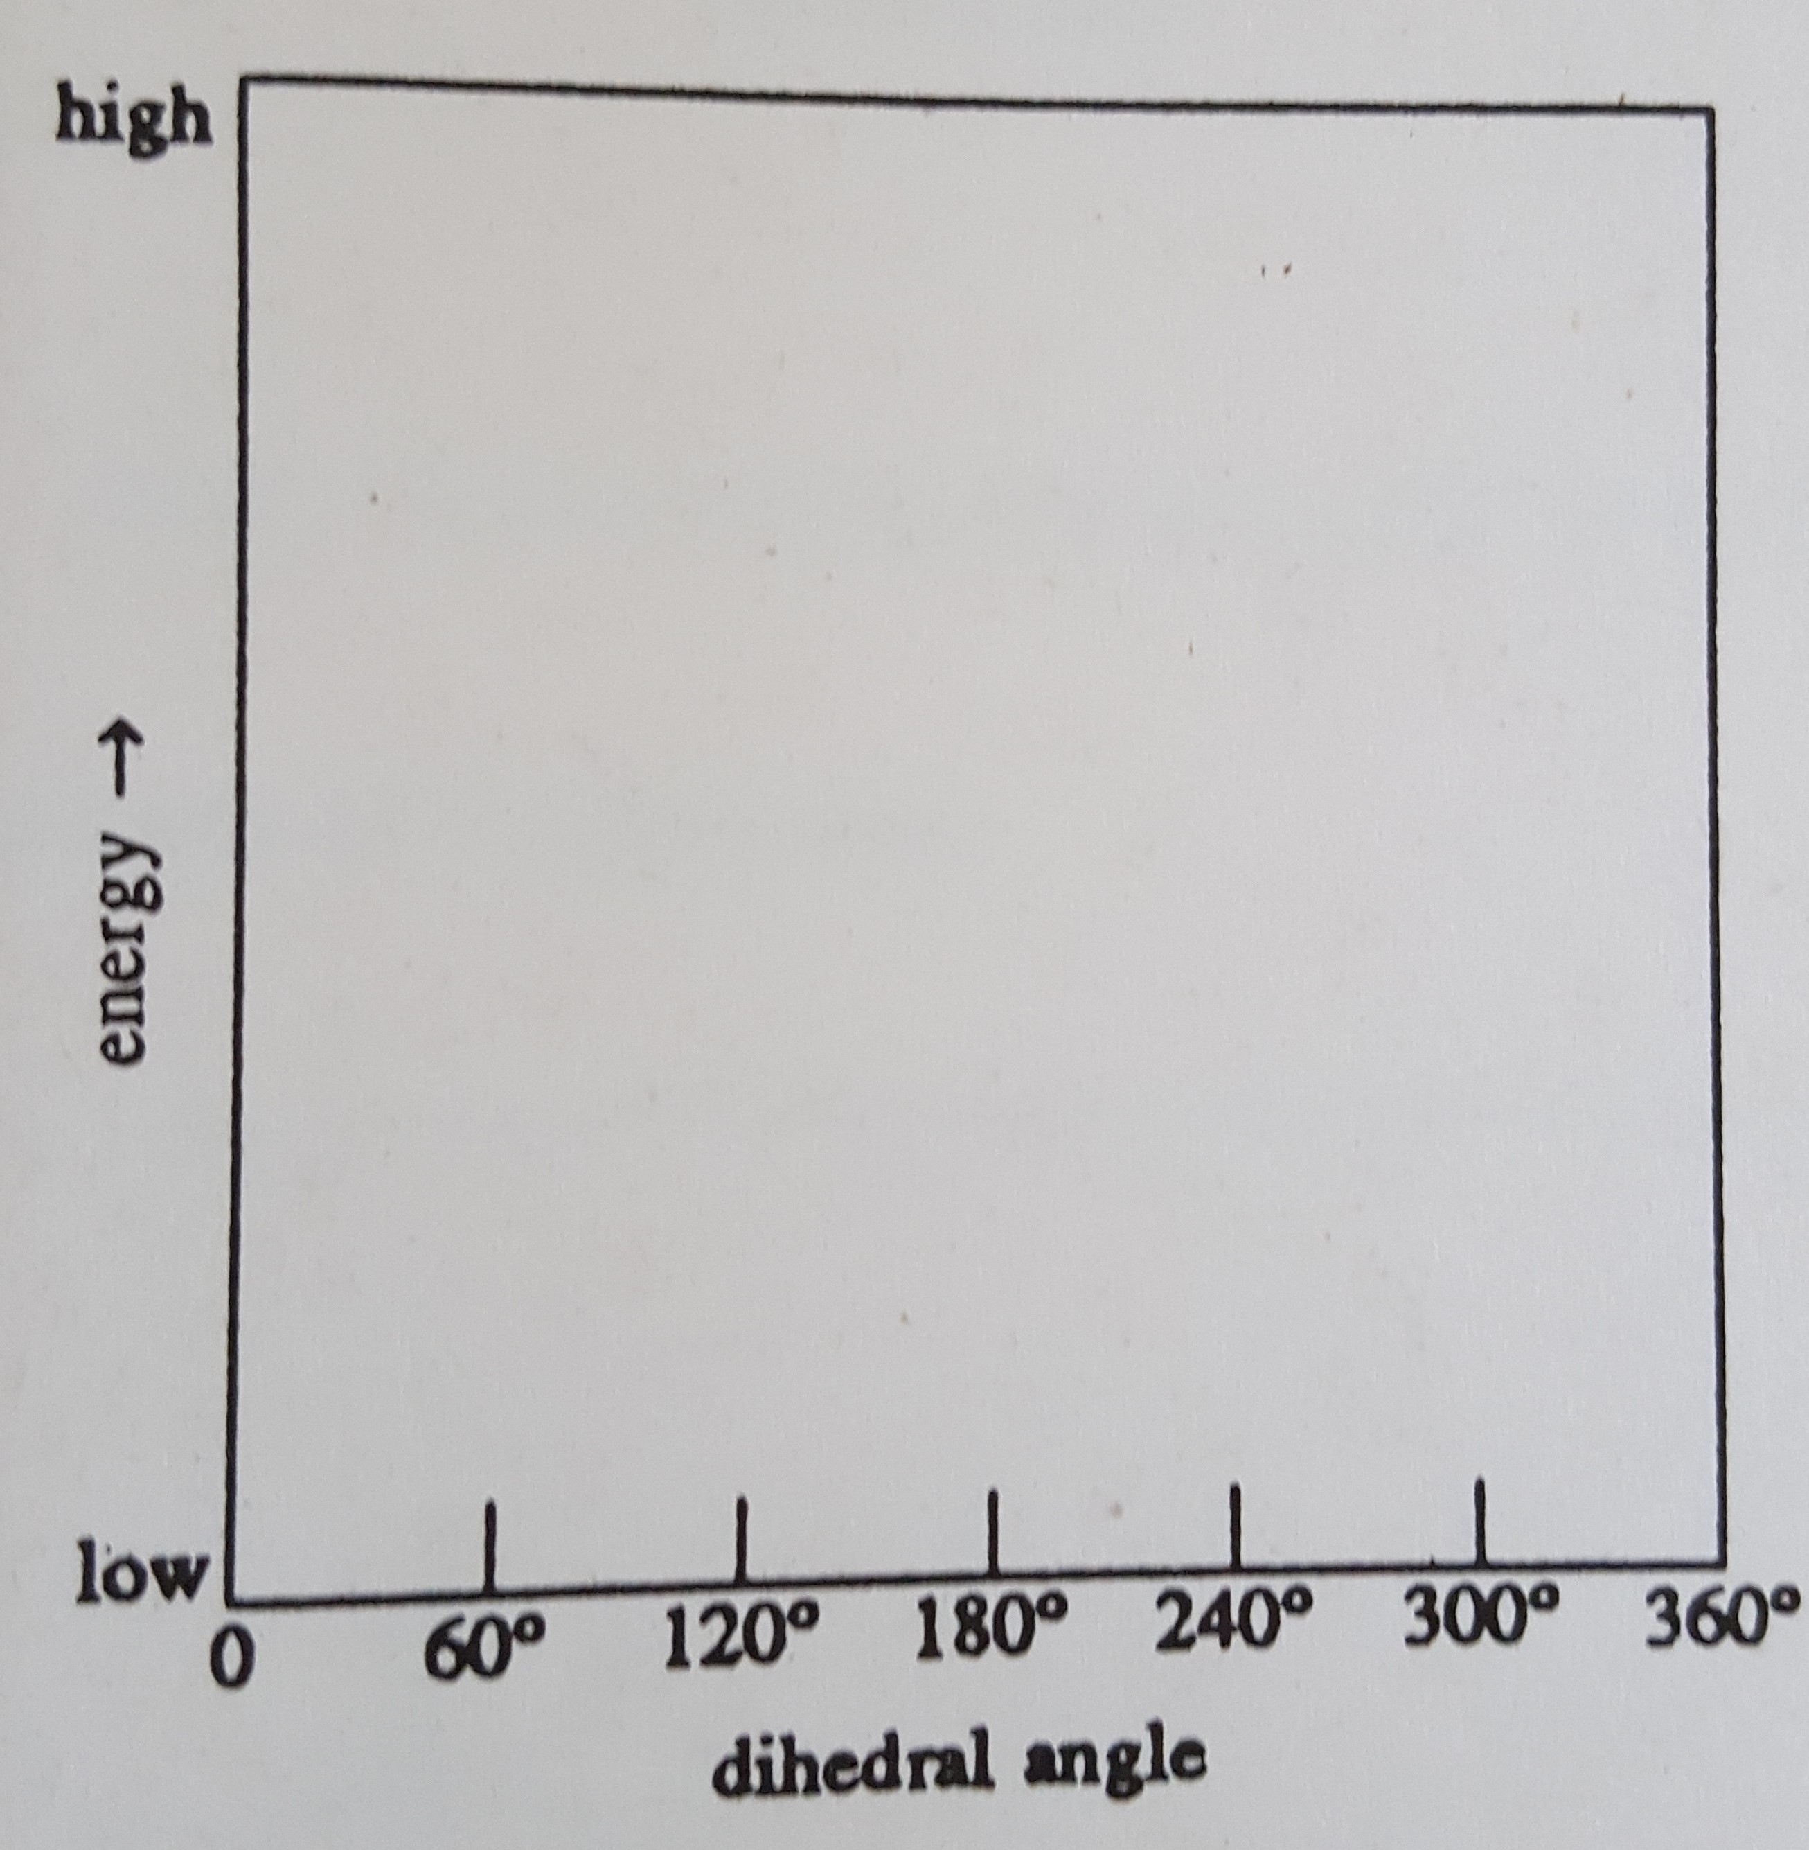
- Graphing: Energy vs. Angle of Ethane

Plot a relative energy curve, showing the maximum peaks and minimum troughs of energy. If two degrees would have the same energy, the graph should demonstrate that.

Suggest holding the model in the eclipsed position, the starting position at 0º. Then turn 60 º at a time. Remember high energy occurs when the hydrogen atoms are the closest together.

- ________________________________________________________________________________

________________________________________________________________________________________

The Conformations of Butane
- DASHED Wedge – SOLID Wedge drawing of butane. NOTE: This is always a side view – drawing should show the “zig-zag” of the carbon chain from the side, as well as whether the hydrogens are pointing “up or down” from the carbon AND whether in plane of carbons vs. pointing forward or backward.

- ________________________________________________________________________________

- Newman projection when fully staggered.,
Position “A” Angle: ____________ (The CH3 groups are how many degrees apart?)

- Additional Newman projections:

Position B Position C Position D
Angles ______& ______ Angles ______& ______ Angles ______& ______
- _________________

- _________________

- ________________________________________________________________________________

- _______ > _______ > _______ > _______
Most Least
stable stable

To determine stability, consider:
1st Staggered vs. eclipsed?
2nd Position of the two CH3 groups relative to each other

- Label angle between the CH3 groups in each of the drawings in #13 & #14 above.

- Graphing: Energy vs. Angle of Butane
**Use your drawings A – D and their bond angles from #13 & #14.
**FIRST, Under each labelled degree on the X axis, write the letter of the appropriate model, A-D. (This will help you use the gradient in #18 to estimate relative energy & plot points)
**2nd: Consider – How is the stability in #18 related to energy?
**Plot a relative energy curve, showing the maximum peaks and minimum troughs of energy. If two degrees would have the same energy, the graph should demonstrate that.
**The energies in this graph will vary more than the previous one for ethane.
**Label each graph point as “s” staggered or “e” eclipsed.

Conformations of Cyclohexane

- _________________

- _________________

- A.________________ B. ______________

- A.______________________________ B. ______________________________

- Drawing of cyclohexane
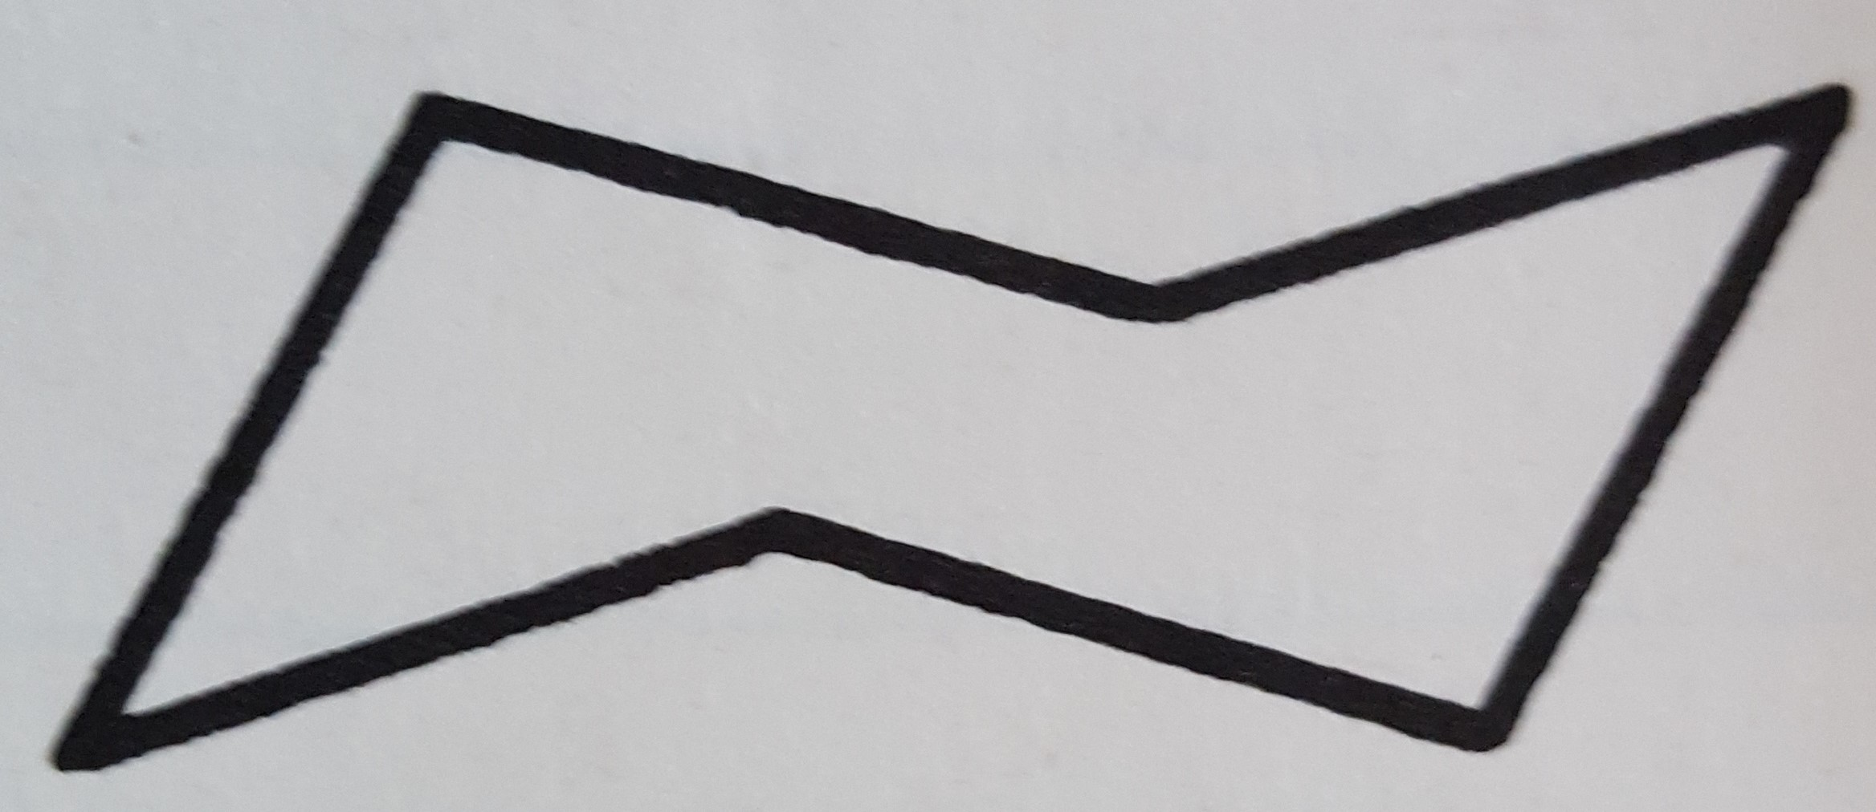

- _________________

- ________________________________________________________________________________

________________________________________________________________________________________

Conformations of Substituted Cyclohexanes, 1-chlorocyclohexane

- Drawing of substituted 1-chlorocyclohexane

- _________________

- Drawing after “ring flip”


- ________________________________________________________________________________

________________________________________________________________________________________

- ________________________________________________________________________________

- _________________

- _________________

- _________________

- ________________________________________________________________________________

________________________________________________________________________________________

- ________________________________________________________________________________

________________________________________________________________________________________

- A. ______________________________

B. ______________________________

- _________________

- ________________________________________________________________________________

________________________________________________________________________________________

- ________________________________________________________________________________

________________________________________________________________________________________

1,3-Dichlorocyclohexane & 1,4-Dichlorocylohexane.

1,3-Dichlorocyclohexane

- _________________

- ________________________________________________________________________________

________________________________________________________________________________________

1,4-Dichlorocylohexane

- _________________

- ________________________________________________________________________________

________________________________________________________________________________________

Summary of Cyclohexane Observations

Cyclohexane: Circle the appropriate choice or complete the sentence.

- Chair vs. boat conformations are more stable conformations because

_________________________________________________________________________.

- Axial vs. equatorial positions are structural vs. configurational/geometric vs. conformational/rotamer isomers, because they __can vs. cannot_________be interconverted by

_________________________________________________________________________.

- Cis vs. trans structures are structural vs. configurational/geometric vs. conformational/rotamer isomers, because they __can vs. cannot_________be interconverted by

_________________________________________________________________________.

- Whether cis or trans is more stable for a set compound (such as 1,2 vs. 1,3 vs. 1,4 substituents)

depends on _________________________________________________________________.

- For the chair conformation, axial positions on adjacent carbons are on the

________________________________________ of the mean plane of the ring.

