Name_________________________Period_____
Modeling Restriction Enzymes & Recombinant DNA
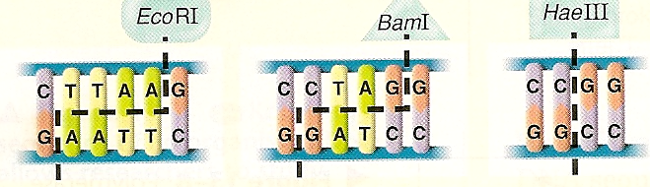
- Make 3 yellow plasmids by taping the ends to form a circle. Now, cut each plasmid with a different restriction enzyme. Write the enzyme used on each piece.
  - For each enzyme, in how many places did it cut the plasmid and how many DNA pieces resulted?

  - Did all 3 enzymes cut the DNA in a manner that allows it to be spliced together with a foreign DNA piece? Explain.

  - Did all enzymes leave the “origin of replication” intact?

  - Discard all plasmid pieces that have blunt ends or are lacking the “origin of replication” region. Keep the remaining pieces to be used in Step #3.

- Now cut 3 blue human DNA segments, each with a different restriction enzyme. (Remember human DNA is NOT circular.) Write the enzyme used on each piece.
  - Did all 3 enzymes cut the DNA in a manner that allows it to be spliced together with a foreign DNA piece? Explain.

  - Did all 3 enzymes leave the insulin gene intact? Explain.

  - Keep only the human DNA pieces that have the insulin gene intact and that have sticky ends on BOTH ends. (If even one end is blunt, discard it.)

- Try to combine the remaining human insulin genes with the remaining plasmid pieces to make a circular plasmid. Remember, base pairs on the sticky ends must match to “stick” together; A-T and G-C. Tape the pieces together. You should be able to make a plasmid.
  - In the recombinant plasmid, what enzyme had been used to cut both the plasmid & human DNA?

  - Instead of tape, what is the name of the enzyme that seals the sticky ends together?

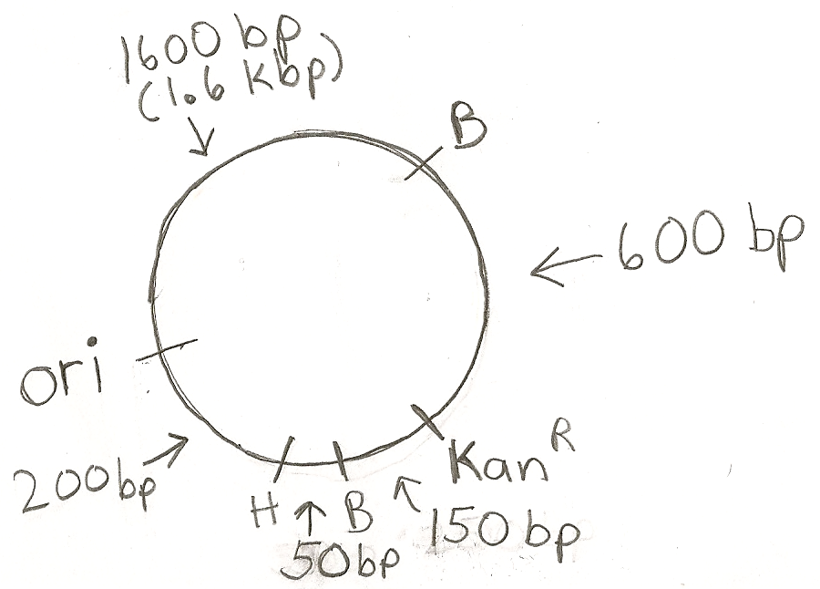
  - Is there a correlation between the enzyme used to cut the human DNA and the enzyme used to cut the plasmid DNA? Explain.

- In the diagram to the right, length is measured in base pairs (bp).
  - What enzyme would you use to obtain the smallest DNA piece that contains the Kanamycin-resistant gene? What would be the size of that small piece?

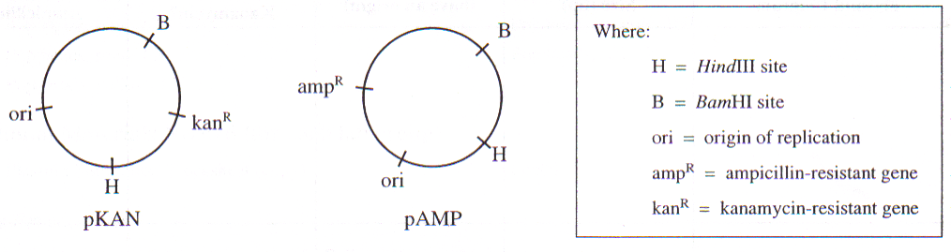
  - What enzyme would you use to obtain the smallest DNA piece that contains the origin of replication? What would be the size of that small piece?

  - For each enzyme, in how many places did it cut the plasmid and how many DNA pieces resulted?

