Name ____________________________Period____
LAB: #19 Oxygen & Growth of Bacteria

Purpose: __________________________________________________________________________________________
__________________________________________________________________________________________________
__________________________________________________________________________________________________
EXPECTED Results:
- Based on the background in your lab manual
- Complete PRIOR to reading the plates
- List expected relative rates of growth using 0/- + ++ +++ ++++
- Classifications possible: Obligate aerobe, obligate anaerobe, aerotolerant anaerobe, microaerophile, facultative anaerobe. NOTE: If the organism is not specifically mentioned in the background reading, use the classification that is stated as the most common.

Organism | Classification, according to background info | Aerobic Growth  Prediction | Anaerobic Growth  Prediction | Catalase  +(Present)/ 0(Absent)
Pseudomonas
Clostridium
Streptococcus
E. coli

ACTUAL Data & Observations & Analysis:
- List the relative rates of growth using 0/- + ++ +++ ++++

- Your ratings should CLEARLY show which plate has the most, least growth, etc.

- CATALASE: Can only be performed if there is growth on the plate. If a blood agar plate is used, the organism must be transferred and tested in an empty petri dish.

- Classifications possible: Obligate aerobe, obligate anaerobe, aerotolerant anaerobe, microaerophile, facultative anaerobe. NOTE: If the organism is not specifically mentioned in the background reading, use the classification that is stated as the most common.

Organism | Aerobic Growth | Anaerobic Growth | Catalase  +(Present)/ 0(Absent) | Classification based on your PLATE growth | Does catalase agree with classification?
Pseudomonas
Clostridium
Streptococcus
E. coli

Thioglycollate Broth Observations
- Color areas pink where the indicator has turned pink.
- Sketch/shade the location of bacterial growth.
- Sketch should reflect variations of growth density at various depths.
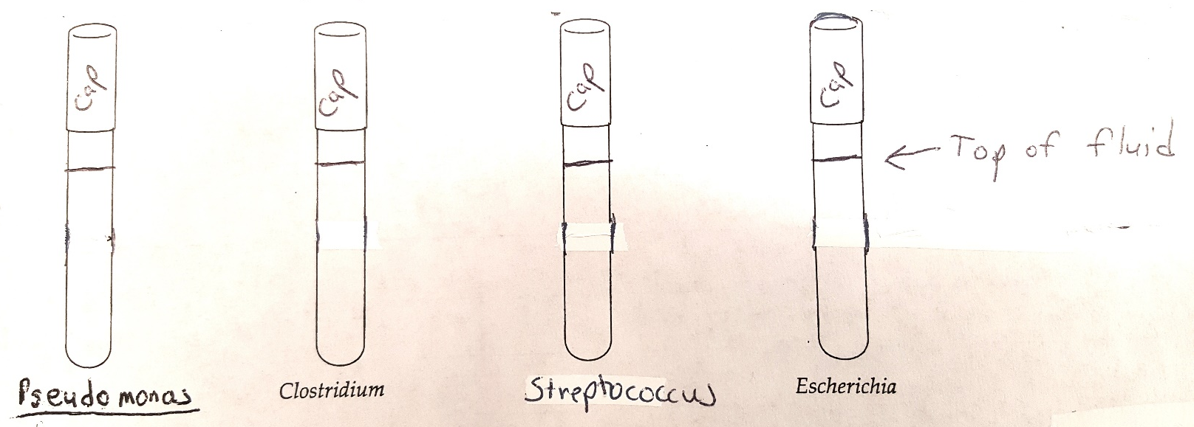

Analysis of Thioglycollate Broth

Organism | Classification based on BROTH growth | Explain what observations your classification is based on
Pseudomonas
Clostridium
Streptococcus
E. coli

Analysis Questions:

- Thioglycollate:
  - If the indicator in the thioglycollate has turned pink, what does that tell you?

  - Thioglycollate broth should not be shaken prior to use. Why not?

  - What classifications can only grow in areas that are NOT pink? Explain why.

  - Obligate anaerobes can grow in thioglycollate even though they are not able to grow in most broths. Name 2 components in the thioglycollate, and describe their mechanism of action, that enable anaerobes to grow. Explain – be specific. (See background information.)

- Anaerobic Jars. Using the background reading, describe the mechanism used in an anaerobic jar to remove attain an anaerobic environment.

- Anaerobic incubators. Large labs may have a special incubator designed specifically for anaerobes. Oxygen is removed through a vacuum. What two gasses are usually added to replace the oxygen?

- Catalase: Bacteria growth from a blood agar plate must be transferred to a slide or petri dish to test for catalase. Explain the error that could occur if the hydrogen peroxide were dropped directly on the colony on the blood plate instead.

- Aerobes vs. anaerobes. There are two main groups of bacteria that the 5 classifications fall under; aerobic vs. anaerobic. Each classification only fits in one of the groups, aerobic vs. anaerobic.
  - Which of the 5 classifications are considered to truly be aerobes?

  - What enzyme(s) must be present to be considered an aerobe?

  - Which of the 5 classifications are considered to truly be anaerobes?

  - Explain why anaerobes can’t grow, or prefer not to grow, in the presence of oxygen. Be specific. List mechanisms they lack and what the results are if they are grown in oxygen.

  - Can some aerobes grow in the absence of oxygen? _________ If all you had was an anaerobic plate (no aerobic plate to compare to), what could you do to determine if the bacteria on the plate in the anaerobe jar were truly an anaerobe or an aerobe?

- For which organisms did your broth classifications match your plate classifications?

- For which organisms did your broth classifications NOT match your plate classifications?

  - What could be possible explanations for the differences?

