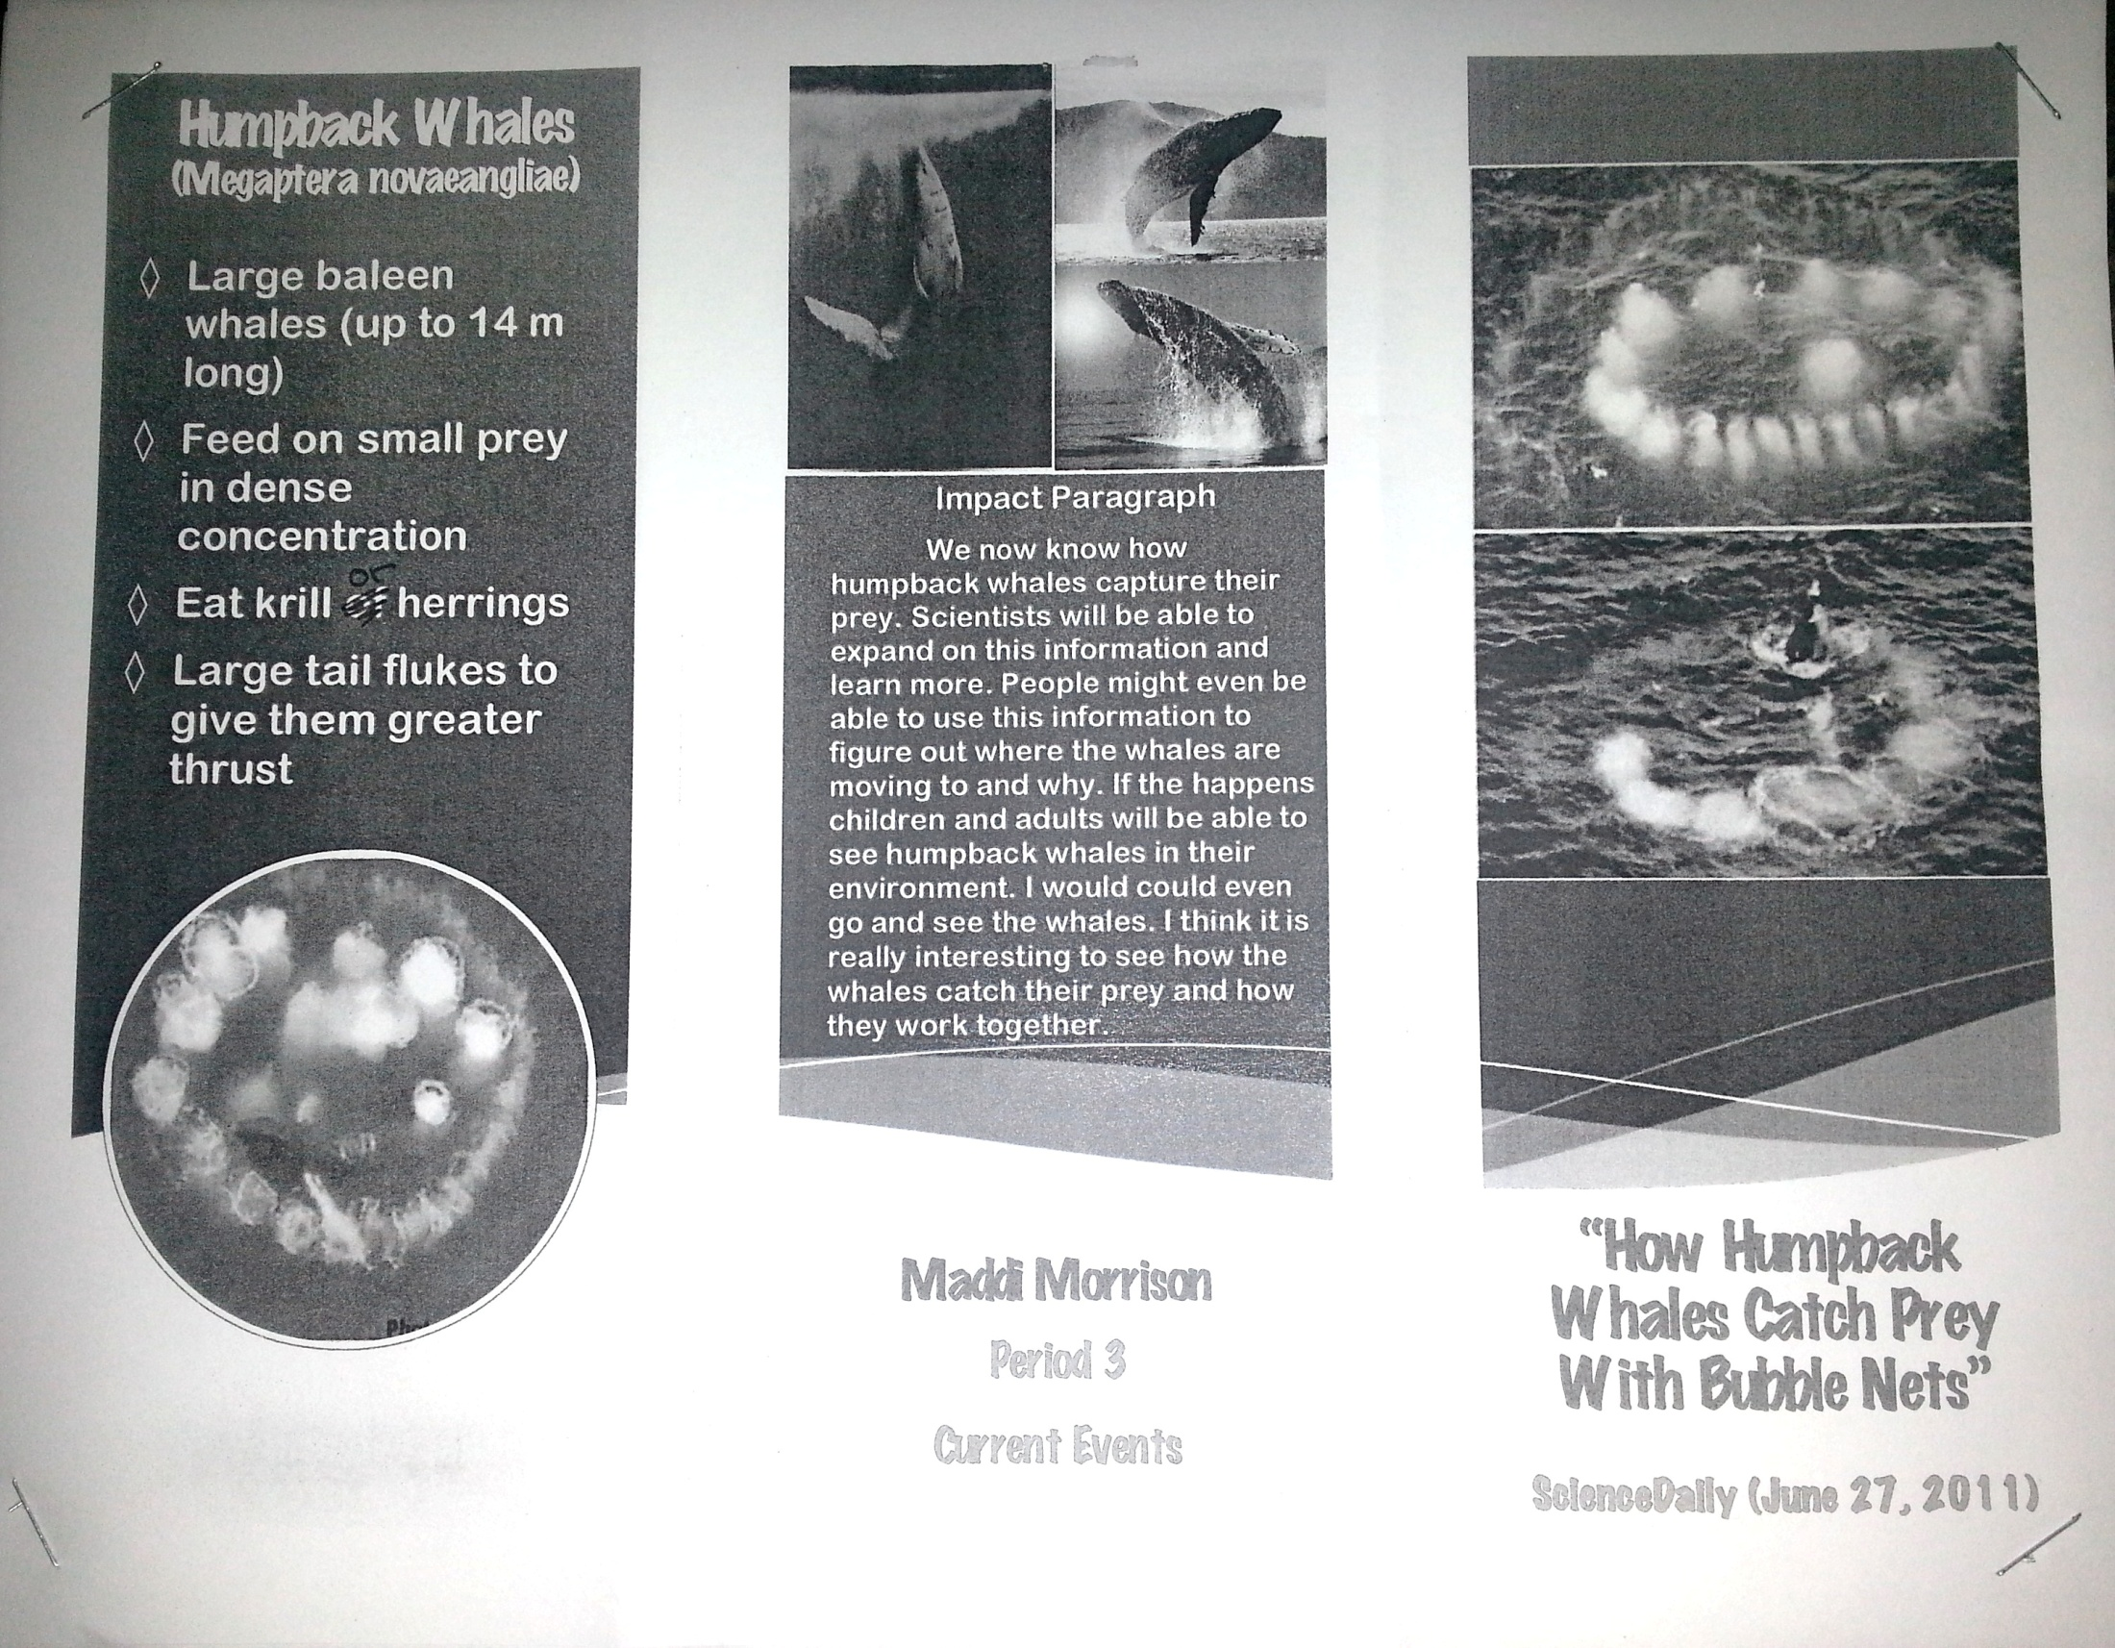

Link: <http://www.sciencedaily.com/releases/2011/06/110624083516.htm>

Photo was here. Be sure to include textbox with web address next to the picture to show source.

Photo was here. Be sure to include textbox with web address next to the picture to show source.

Photo was here. Be sure to include textbox with web address next to the picture to show source.

First Last (Your name)

Period 2 (Your period)

Current Events (Assignment)

8/29/2013 (Your Due Date)

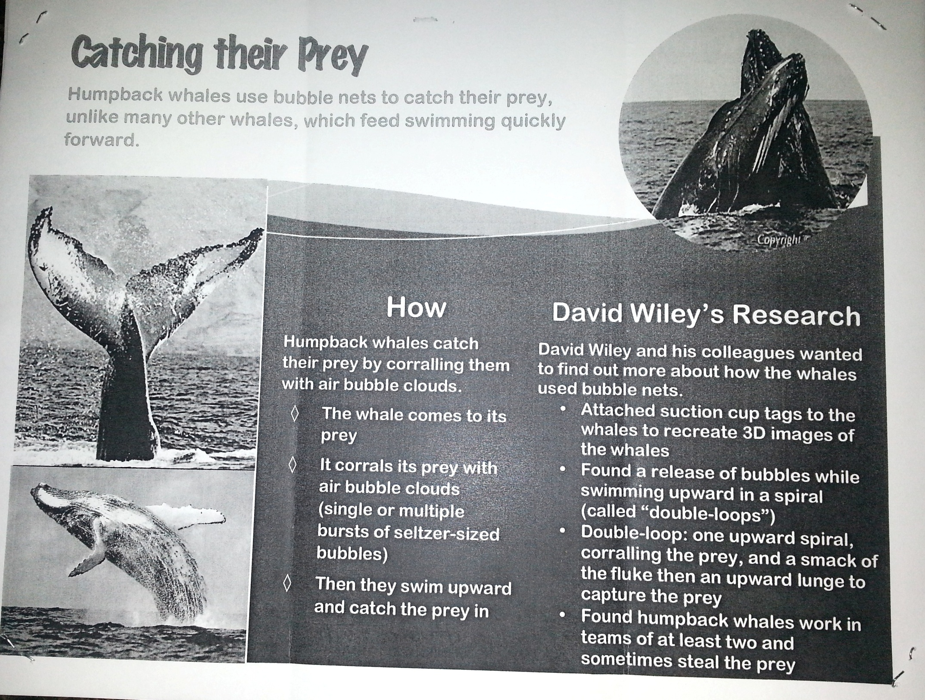

Photo was here. Be sure to include textbox with web address next to the picture to show source.

Photo was here. Be sure to include textbox with web address next to the picture to show source.